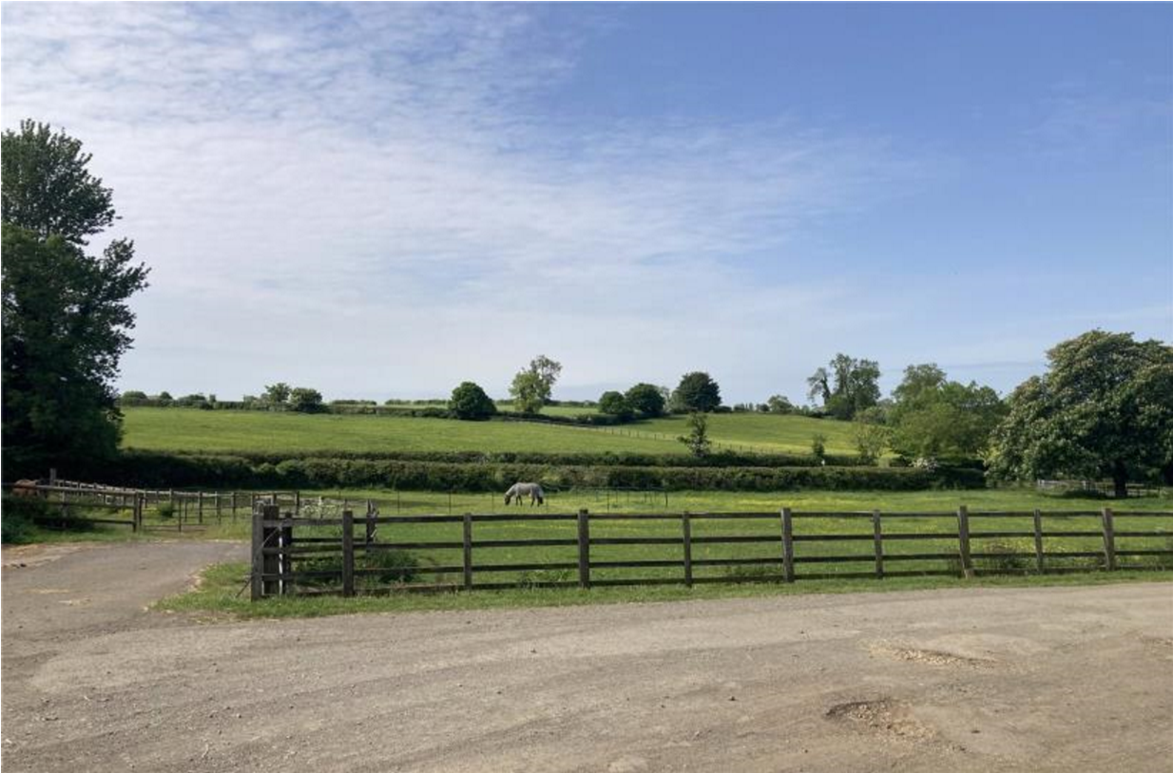
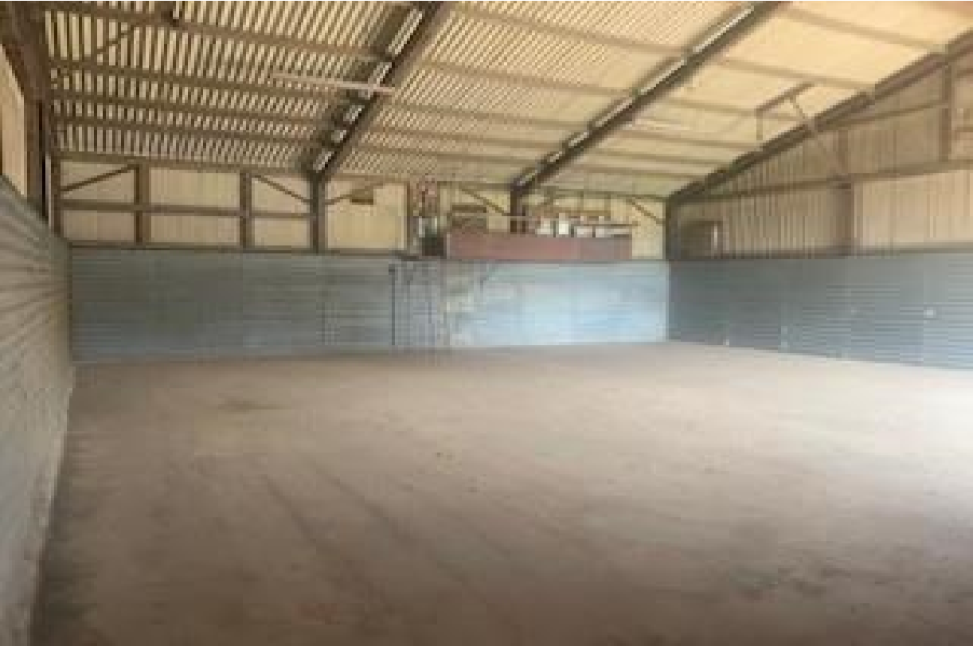
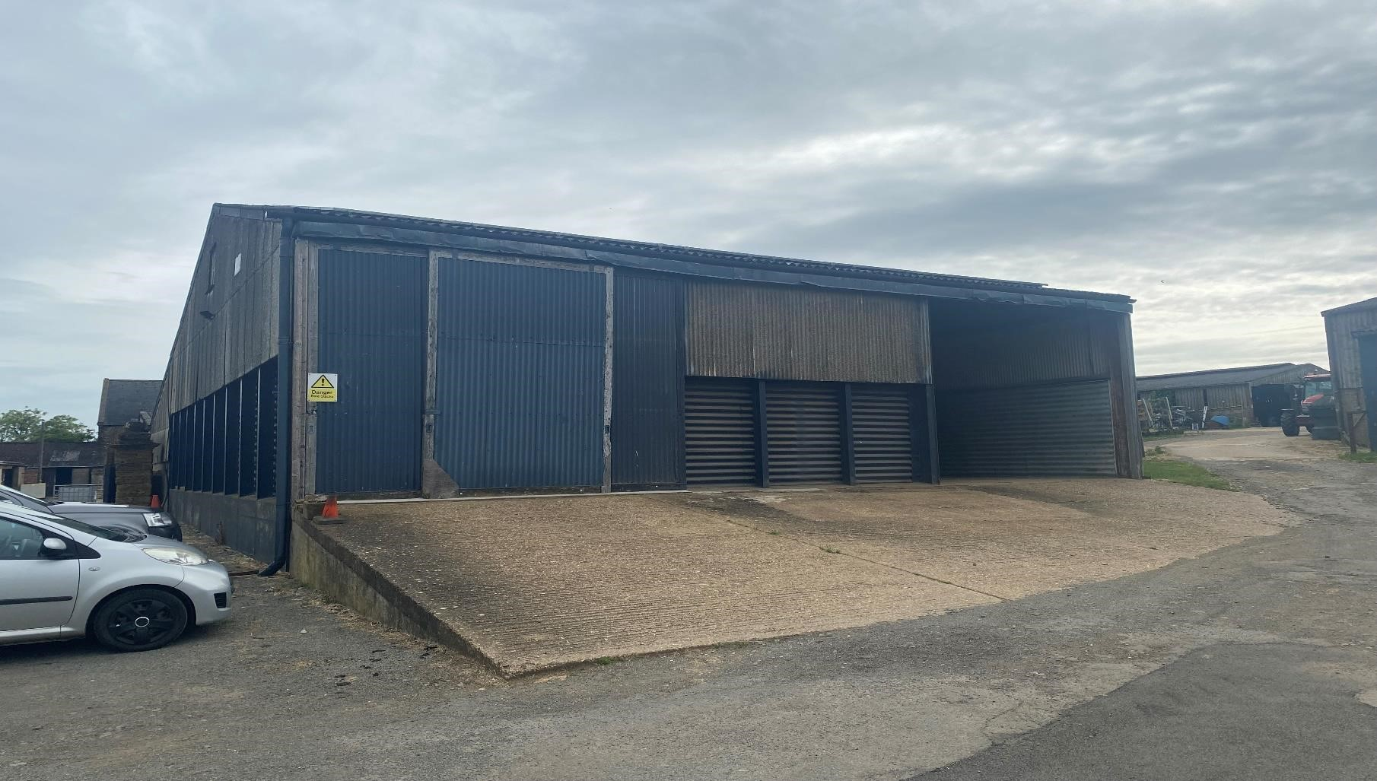

Walgrave | Northamptonshire | NN6 9QG

•

Located in a rural setting with attractive
views

•

Approx. size

2
,249ft
²

•

Eaves height

of approx. 4m

•

Asking rent of £13,500 per annum exclusive

berrys.uk.com

The barn is situated on Hall Farm which is accessed off Walgrave Road and South East of the village of Walgrave.

Walgrave is a small village in Northamptonshire which is just off the A43 linked between Kettering and Northampton.

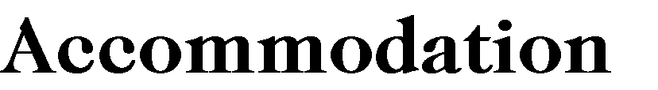
The property has been measured on a gross internal basis and is approximately 2,249ft² (209m²) and comprises the following areas:

This detached barn has been historically used as storage for Hay Grain etc. The barn is of steel portal frame construction with a pitched roof and has timber sliding doors to the front elevation, a concrete floor internally and concrete apron to the front which slopes. Eaves height of approx. 4 mtrs.

The property is available by way of a new lease at an asking rent of £13,500 per annum exclusive of all other outgoings.

The property is exempt from Business rates due to its agricultural status
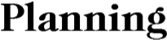
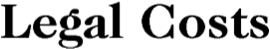
The property is used for agricultural purposes.

The property benefits from mains 3 phase electricity.
Each party to bear its own costs. However, the ingoing tenant is to first provide a legal undertaking to cover the landlords abortive legal fees in the event the tenant withdraws from the transaction once terms are agreed.

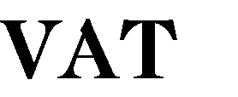
VAT is not applicable to the rent.

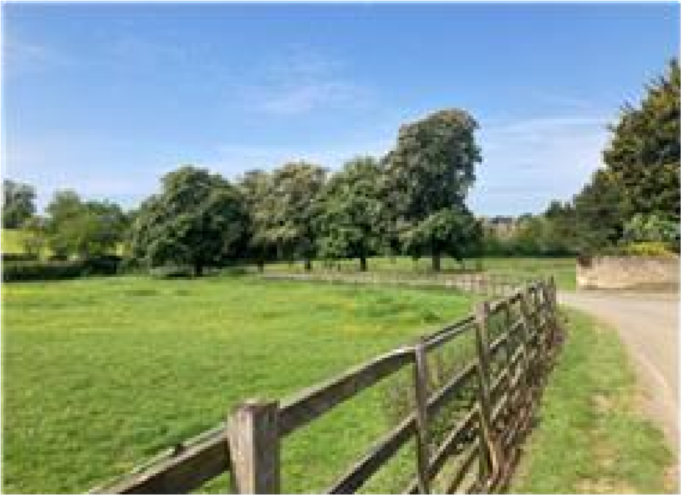
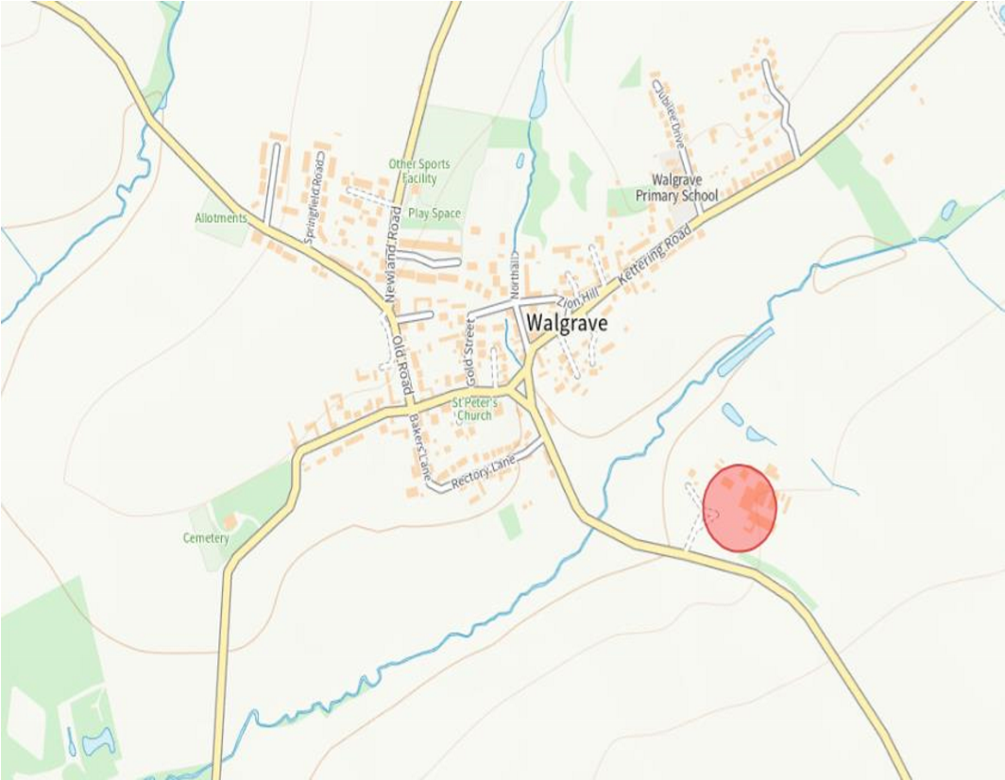
Kettering, NN15 7QX—0300 1263000

North Northants Council, Municipal Offices, Bowling Green Road,

Jason Sadler or Kevin O’Dell
T: 01536 517777 | E: jason.sadler@berrys.uk.com

42 Headlands, Kettering, Northamptonshire, NN15 7HR

Berrys, their clients and any joint agents give notice that:
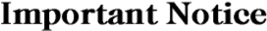
- These particulars are prepared for the guidance only of prospective purchasers 4. The photographs appearing in these particulars show only a certain part and and are intended to give a fair overall description of the property but do not aspect of the property at the time when the photographs were taken. Certain
form part of any offer or contract. aspects may have changed since the photographs were taken and it should not
- Any information contained herein (whether in the text, plans or photographs) is be assumed that the property remains precisely as displayed in the photographs. Furthermore no assumptions should be made in respect of parts given in good faith but should not be relied upon as being a statement or representation of fact. of the property which are not shown in the photographs.
- Nothing in these particulars shall be deemed to be a statement that the 5. Any areas measurements or distances are approximate.
property is in good condition or otherwise, that any service or facilities are in 6. They are not authorised to make or give any representation or warranty good working order, or that the necessary statutory requirements have been whatsoever in relation to the property. met. 7. Purchasers must satisfy themselves by inspection or otherwise.

